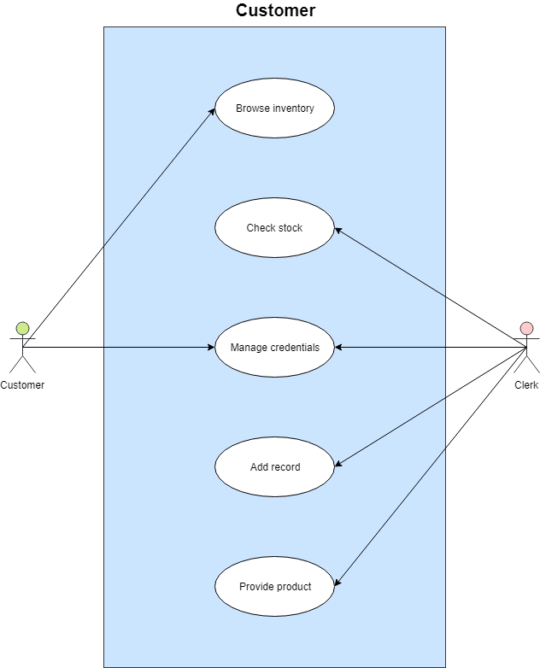

**Brief Description**

This use case allows a customer to buy a TV from a clerk in MCTV.

**Flow of Events**

**Activation**

This use case begins when a customer arrives at a checkout with their selected TV.

**Basic Flow**

1. The customer browses the inventory and chooses a TV.
2. The clerk checks if that product is in stock.
3. Once it is confirmed that the product is in stock, the customer and clerk manage the credentials such as payment method.
4. The customer pays the clerk.
5. The clerk records the payment into the system.
6. The clerk provides the product with a receipt and the customer leaves.

**Alternative Flows**

1. If the customer has insufficient money, the transaction is cancelled until further notice or until it can be paid for.
2. If the product is not available, the customer may choose to wait or choose an alternative.

**Special Requirements**

None.

**Pre-Conditions**

The Customer must be registered in the system before this use case begins.

**Post-Conditions**

If the use case was successful, the payment details for the customer are updated on the system.

**Extension Points**

None.